

EAS project Oy

Concise installation and set-up manual

for WooCommerce™ EAS EU compliance™ Plugin

Version 1.1 09.09.2021

# Copyright

## Easy Access Systems

EAS EU Compliance and EAS Project are trademarks of Easy Access Solution Project Oy or ”EAS”. Unauthorized use is prohibited. EAS EU Compliance is an official WooCommerce plugin.

Nothing contained herein shall be constructed as conferring any license or right under any EAS patent, copyright, or trademark.

The owner’s address:

* c/o Technopolis Ruoholahti
* Hiilikuja 3
* 00180 HELSINKI

## WooCommerce

Automattic Inc. owns and oversees the trademarks for Woo™, WooCommerce®, and WooThemes® names, logos, and related icons.

The owner’s address:

* 60 29th Street #343
* San Francisco, CA 94110
* United States of America

# Plugin installation and setup

## Backup of tax settings before the Plugin installation

Before installation of the Plugin is performed, one should backup internal WooCommerce tax settings and deactivate other EU VAT related plugins.

Before making any changes to tax setting in your standard WooCommerce menu:

*Figure 1*

1. Choose “Standard rate”.
2. Save existing settings to CSV file (to enable easy reinstall) to the chosen location

Repeat above actions for “Reduced rate rates” and “Zero rate rates”

Deactivate any third-party plugins that enable the calculation of EU taxes in your “plugin” options. Make sure to save any information /settings required for the installation/activation of these plugins.

Any Non-EU country tax settings (for countries where the deliveries are made to) should be left in the list, while any tax settings to EU countries should be deleted manually (compare Figure 2 below to Figure 1 above).

Export the settings into the CSV file again (in case you need to upload only non-EU settings if something goes wrong and all the non-EU settings need to be reinstalled).

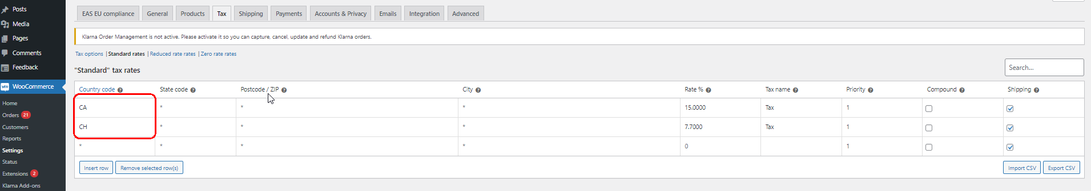

*Figure 2*

Make sure to press “Save changes” before continuing.

## Backup of products settings before the Plugin installation

Proper backup of your existing products setting is essential for ensuring safe removal of the Plugin and safety of your commercial data. We recommend that procedures described in this section are to be repeated also after the plugin installation as part of quality assurance and data safety internal procedures. To back up your merchandise data, please, follow the following steps:

1. Choose the “Products” menu option in the store operator menu view. And then press the “Export” button.

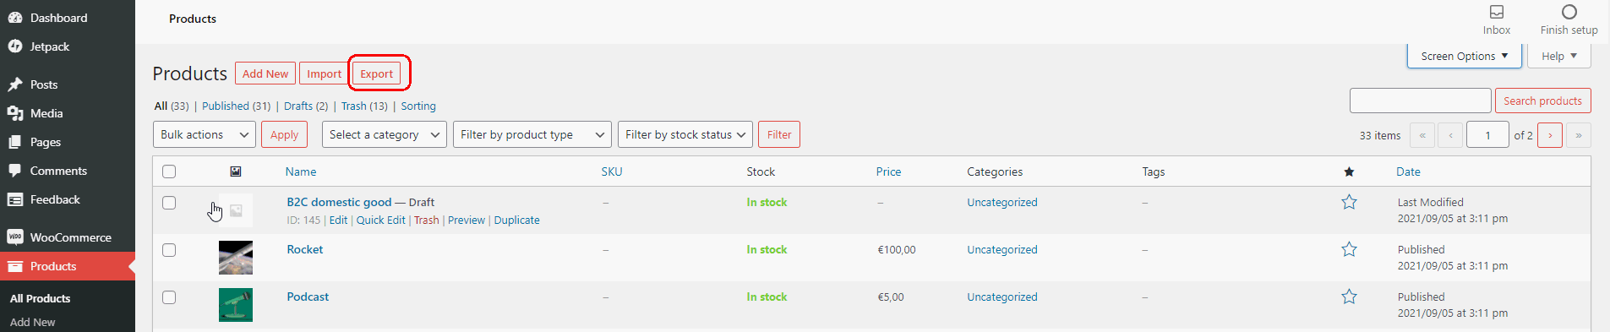

*Figure 3*

1. A new communication window will open (see Figure 4 below).

Tick the “Yes, export all customs meta” box and press the “Generate CSV” button.

When prompted save the resulting CSV file to your local machine. Keep track of back-ups as part of your usual maintenance and backup routines.

*Figure 4*

1. Data can be always restored to the WooCommerce store by uploading a saved CSV file by pressing the “Import” button (see item 1 above).

## Manual installation

Before installation of the Plugin please make full backup of your database and store files. Please follow <https://docs.woocommerce.com/document/backup-wordpress-content/>

You can install the Plugin manually or via the WooCommerce marketplace. Manual installation should follow the following steps:

1. Download .zip archive from the following link: <https://github.com/EAS-project-oy/easwoocommerce/archive/refs/heads/main.zip>
2. Open administrators Dashboard of your WooCommerce instance.
3. Navigate to Plugins → Add new.

*Figure 5*

1. In the window press button “Upload Plugin”.

*Figure 6*

1. Press the button “Choose File”.
2. Select previously downloaded file (EAScompliance-main.zip).
3. Press the button “Install now”.

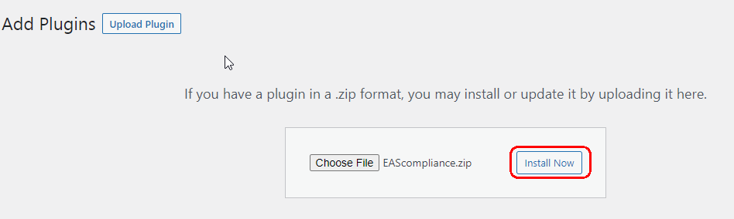

*Figure 7*

1. Once the installation is finished, press the button “Activate plugin”.

*Figure 8*

1. Installation is now finished. Please, follow to the configuration section of the Plugin to set it up for commercial use (see Section 1.5).

## Installation from WooCommerce marketplace

The Plugin is also available for download from the WooCommerce marketplace:

[https://woocommerce.com/EAS system-category/woocommerce-extensions/marketing-extensions/](https://woocommerce.com/product-category/woocommerce-extensions/marketing-extensions/)

Please, refer to the WordPress plugin installation documents to install the Plugin:

<https://docs.woocommerce.com/document/managing-woocommerce-com-subscriptions/>

## Plugin initial configuration

Step 1. General EAS EU compliance plugin view

Upon enabling the Plugin, the “EAS EU compliance” settings page will be available in WooCommerce → Settings → EAS EU compliance tab:

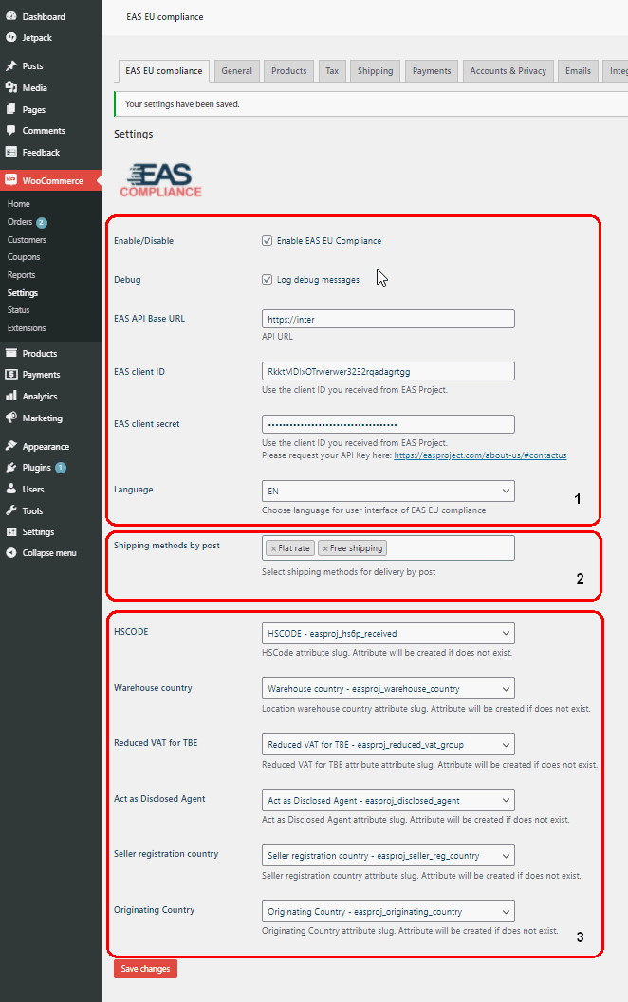

EAS EU compliance plugin connection settings (item 1 on the left) are described in detail in Step 2. below.

EAS EU compliance plugin delivery methods (item 2 on the left) settings are described in Step 3. below.

EAS EU compliance special attributes mapping (item 3 on the left) is described in Step 4. below.

*Figure 9*

Step 2. Connection settings

*Figure 10*

Input the following connection point for connection to EAS system API (item 1 above): https://manager.easproject.com/api. Sign up with EAS Project to obtain authorization keys (items 2,3) via the EAS self-registration system: <https://registration.easproject.com>

If you already registered, then obtain authorization keys in Merchant Dashboard <https://dashboard.easproject.com> (For more information about delivery options please refer to Operation manual for EAS EU compliance™ system integrated via EAS WooCommerce™ Plugin)

Set the language interface (item 4 above) for the Plugin (EN for English is set by Default).

Tick the box “Enable EAS EU compliance” and press ‘Save changes’ to test connection with API and create necessary EAS system attributes.

If wrong credentials are input Plugin won’t activate and an error message will be displayed.

Step 3. Assigning delivery methods

Delivery methods are assigned after the Plugin is installed (For more information about delivery options please refer to Operation manual for EAS EU compliance™ system integrated via EAS WooCommerce™ Plugin). The whole list of available shipping methods can be seen by clicking on the shipping methods window:

*Figure 11*

Clicking on the window produces the list of all available shipping methods (see Figure 10).

In the EAS EU compliance folder choose all shipping methods that are to be considered as “postal” (chosen postal methods will be shown in the window (1)) next to the field “Shipping methods by post” as shown in Figure 11. Removing of postal shipping method is done by pressing “x” next to the shipping method: 

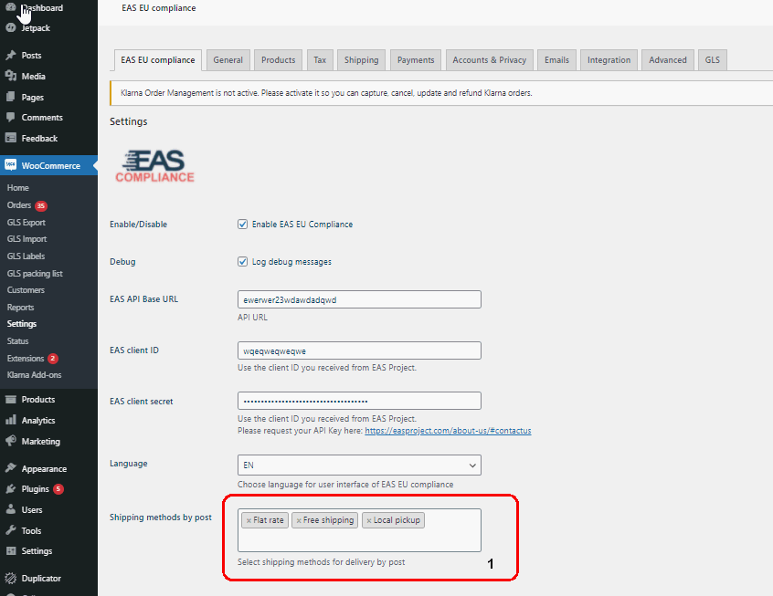

*Figure 12*

All other shipping methods (that are not included in the list of postal delivery methods) are considered as “courier” delivery methods.

Always press “Save changes” at the bottom of the page after any changes on the Plugin set-up page (bottom of the page).

Step 4. Mapping of merchandise additional attributes

Straight after the Plugin installation, the EAS system will create additional attributes for Merchant’s products.

The Merchant shall ensure mapping of existing attributes to additional attributes created by the Plugin. Mapping procedures depend on the number of merchandise attributes existing in the Merchant’s WooCommerce E-shop setting.

The initial settings of EAS EU compliance system special attributes are presented in the figure below.

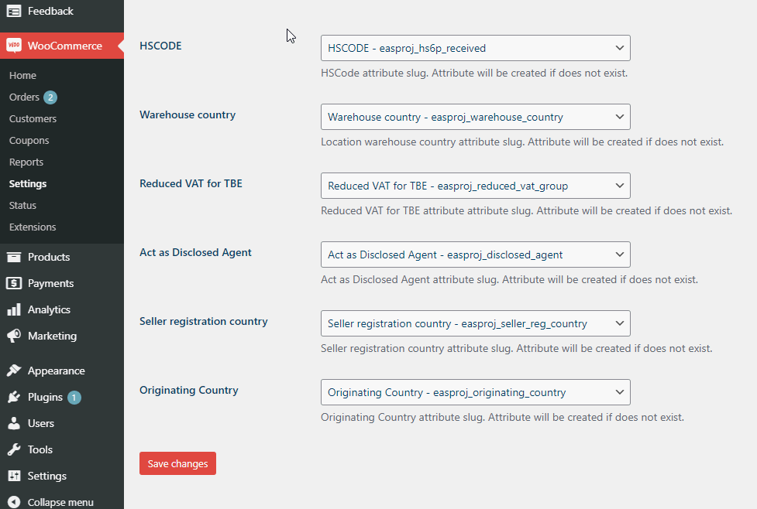

*Figure 13*

The merchant shall analyse existing merchandise attributes that are present in the Merchant’s store to identify if currently existing attributes already contain the data that is needed for the operation of the EAS system.

Full description of the special attributes mapping process is available in the “*Operation manual for EAS EU compliance™ system integrated via EAS WooCommerce™ Plugin”.* This document becomes available after the registration in the EAS Self-registration system.

Step 6. Enabling of shipping to the EU countries

Choose the “Shipping” menu option and add either the whole Europe (as an identified region in WooCommerce) as the allowed destination region or all individual countries where you deliver to. The EAS solution will be operational in all 27 countries of the EU. Make sure that all other regions where you deliver your products are displayed (see Figure 19 below).

*Figure 14*

In the example, the whole European region is chosen.

Step 7. Ensuring of existing of EU compliance tax settings

Check that the EAS EU compliance tax setting is present in the “Standard rate” window view

*Figure 15*

If at that stage your settings for non-EU countries are missing you can easily import the settings saved previously into the CSV file (see Section 1.1)

Make sure you import settings without EU VAT countries. If you see any EU countries in the list after CSV file upload, just delete such entries manually.

Make sure to press the “Save changes” button.



Ensure that the “Shipping” button is ticked for all entered VAT zones/countries, as shown in Figure 20.